**Assembly Instructions:**

1. Once you obtain your STM32 nucleo board and install STM32CubeIde on your PC, gather all components, wires, and breadboard as shown in Figure D-1.
2. Connect all wires and components as shown in Figure D-1.
3. Connect mini USB connecter from PC to STM32 board. If you plan on communicating with the microcontroller through UART, then to connect the RS232 connector instead of the USB.
4. Connect radio to the audio jack shown in Figure D-1, using a 3.5 mm audio cable.
5. Open STM32CubeIDE project file on GitHub repository: https://github.com/TNCMCU/tree/master/Software/MCUTNC. This should open the STM32CubeIDE application on PC.
6. On the left side of the IDE is where you can open the project. Open the main.c file, under MCUTNC > Core > Src > main.c, as shown in Figure E-#
7. Build and run code to STM32 by click the icons shown in Figures E-# and E-#
8. Insert message to be sent to other TNCs, with specific address and number of digipeaters.

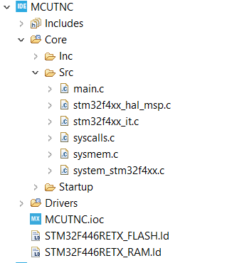

Opening project



Build icon



Run icon